Introduction To Cycle GAN Model
Introduction:
Generative Adversarial Networks (GANs) are a class of machine learning techniques that consists of two networks playing an adversarial game against each other. They are designed to generate new, realistic-looking data by learning from existing data. They were introduced by Ian Goodfellow in 2014.
A Cycle GAN is a type of generative adversarial network designed for image-to-image translation without paired training data. In simpler words, it can learn to convert images from one domain to another domain without needing one-to-one image pairs.
Examples:
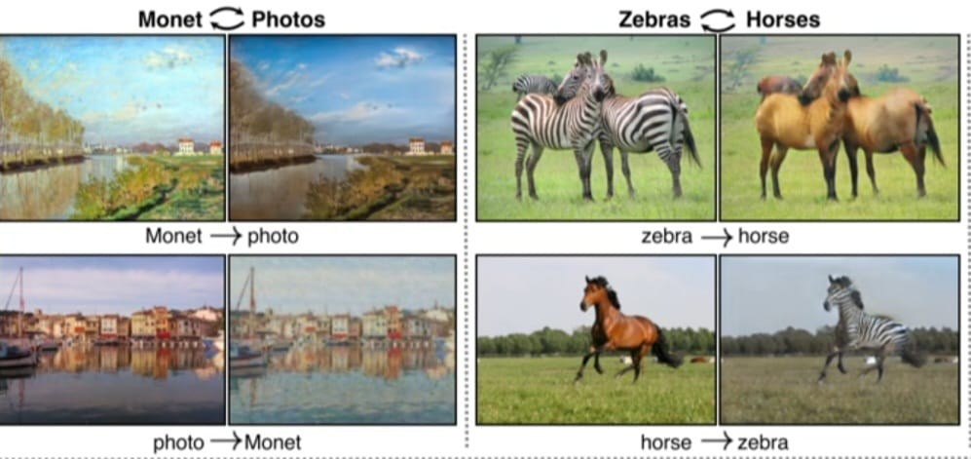

In this pictorial representation, we can see the picture of zebra(domain1) is converted into horse(domain2) and vice versa. Similarly, Monet is converted into picture and vice versa. This image perfectly illustrates the concept of Cycle GAN. Cycle GAN can transform images from one domain to another and back without requiring paired training examples.
The key innovation of Cycle GAN is cycle consistency. If you take a Monet painting, convert it to a photo, and then convert that photo back to a painting, you should ideally get something close to the original Monet. Similarly, converting a zebra to a horse and back to a zebra should yield the original zebra. The image implies this process by showing both directions of transformation.
Cycle GAN uses two generators and two discriminators The generators learn to create convincing translations, while the discriminators ensure the outputs match the target domain.
Components:
Cycle GAN consists of three types of components: Two Generators, Two Discriminators, Adversarial Loss, Cycle Consistency Loss.
- Generators: These are neural networks designed to create new data samples that resemble the training data. In Cycle GAN, a generator takes an image from one domain and transforms it into an image of another domain. The goal is to produce realistic outputs that can "fool" the discriminator. Generators learn through feedback from the discriminator and cycle consistency loss.
The first generator transforms images from the source domain to the target domain. The second generator performs the reverse translation.
- Discriminators: These are neural networks that act as judges, determining whether a given image is real or fake. In Cycle GAN, each domain has its own discriminator, which evaluates the authenticity of the generated images and helps train the generators by providing adversarial feedback.
The first discriminator evaluates the realism of images in the target domain and the second discriminator assesses images in the source domain.
- Adversarial Loss: This loss ensures that the generated images are indistinguishable from real images in the target domain. Each generator tries to fool its corresponding discriminator, while the discriminators aim to correctly classify real vs. generated images.
- Cycle Consistency loss: This loss enforces that an image, after being translated to the target domain and back to the source domain, should be similar to the original image. It helps maintain the integrity of the translation process
Working:
The model architecture is comprised of two generator models: one generator (Generator-A) for generating images for the first domain (Domain-A) and the second generator (Generator-B) for generating images for the second domain (Domain-B).
Domain-B -------- Generator-A --------- Domain-A
Domain-A ---------> Generator-B ---------> Domain-B
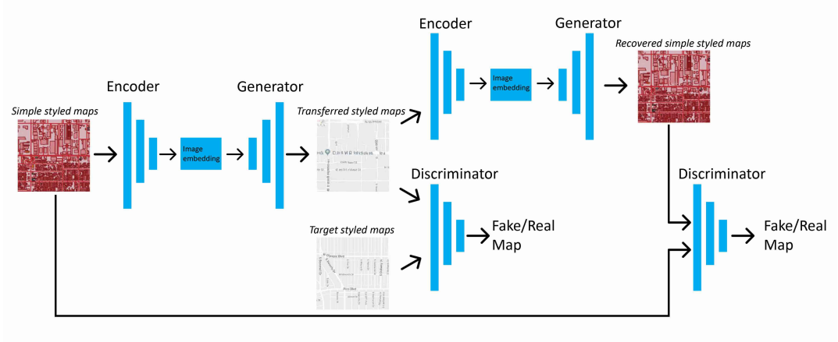
Each generator has a corresponding discriminator model (Discriminator-A and Discriminator-B). The discriminator model takes real images from Domain and generated images from Generator to predict whether they are real or fake.
Domain-A -------> Discriminator-A --------> [Real/Fake]
Domain-B --------> Generator-A ---------> Discriminator-A -> [Real/Fake]
Domain-B ---------> Discriminator-B -------> [Real/Fake]
Domain-A ----------> Generator-B -----------> Discriminator-B -------> [Real/Fake]
The loss used to train the Generators consists of three parts:
- Adversarial Loss: We apply Adversarial Loss to both the Generators, where the Generator tries to generate the images of it's domain, while its corresponding discriminator distinguishes between the translated samples and real samples. Generator aims to minimize this loss against its corresponding Discriminator that tries to maximize it.
- Cycle Consistency Loss: It captures the intuition that if we translate the image from one domain to the other and back again we should arrive at where we started. Hence, it calculates the L1 loss between the original image and the final generated image, which should look same as original image. It is calculated in two directions:
- Forward Cycle Consistency: Domain-B -> Generator-A -> Domain-A -> Generator-B -> Domain-B
- Backward Cycle Consistency: Domain-A -> Generator-B -> Domain-B -> Generator-A -> Domain-A
- Identity Loss: It encourages the generator to preserve the color composition between input and output. This is done by providing the generator an image of its target domain as an input and calculating the L1 loss between input and the generated images.
References:
1). Dataset
2). CycleGAN implementation
3). CycleGAN_Working

